Image Classification for Medical Diagnosis Using Deep Learning

Abstract:
Pneumonia is a serious respiratory disease that affects millions of people worldwide and requires timely diagnosis to reduce morbidity and mortality. Traditional diagnosis of pneumonia from chest X-ray images relies heavily on radiologists, making the process time-consuming and susceptible to human error. This project presents an end-to-end deep learning-based medical image classification system for automated pneumonia detection from chest X-ray images. The system was developed using Python, TensorFlow, Keras, NumPy, Scikit-learn, DVC, and GitHub, following a structured four-phase implementation approach.
The project began with the development of a Baseline Multi-Layer Perceptron (MLP) model, followed by an Advanced Neural Network incorporating Batch Normalization, Dropout, L2 Regularization, and gradient clipping to improve generalization and reduce overfitting. To achieve higher classification performance, transfer learning techniques were implemented using pre-trained convolutional neural network architectures, including MobileNetV2, VGG16, and ResNet50. Fine-tuning strategies were applied to optimize feature extraction from chest X-ray images. Furthermore, ensemble learning techniques were employed to combine the predictions of multiple models and improve overall robustness and accuracy.
Comprehensive data preprocessing and augmentation techniques, including image normalization, rotation, zooming, flipping, and shifting, were utilized to improve model generalization. Class imbalance was addressed using class-weighted loss functions. Model performance was evaluated using Accuracy, Precision, Recall, F1-Score, Area Under the ROC Curve (AUC), Confusion Matrix, and Classification Reports. Explainable Artificial Intelligence (XAI) techniques were incorporated through Grad-CAM visualization, enabling interpretation of model predictions by highlighting important image regions influencing classification decisions.
The developed solution demonstrates the effectiveness of deep learning and transfer learning techniques for automated pneumonia detection in medical imaging applications. The project successfully integrates data preprocessing, model optimization, evaluation, explainability, automated testing, and reproducible machine learning workflows, providing a practical healthcare AI solution that can support radiologists in early disease detection and clinical decision-making.

Keywords:
Keywords— Deep Learning, Medical Image Classification, Pneumonia Detection, Chest X-Ray Analysis, Transfer Learning, MobileNetV2, VGG16, ResNet50, Ensemble Learning, Convolutional Neural Networks (CNNs), TensorFlow, Keras, Data Augmentation, Explainable AI (XAI), Grad-CAM, ROC-AUC, Computer Vision, Healthcare Analytics, DVC, Image Classification.

Content for Keywords Section:
The proposed system leverages modern deep learning and computer vision techniques for automated pneumonia detection from chest X-ray images. The project incorporates image preprocessing, data augmentation, class balancing, transfer learning using MobileNetV2, VGG16, and ResNet50 architectures, ensemble learning, and explainable AI through Grad-CAM visualization. Model performance is evaluated using accuracy, precision, recall, F1-score, ROC-AUC, confusion matrix analysis, and classification reports. TensorFlow, Keras, Scikit-learn, and DVC are utilized to build a scalable, reproducible, and efficient medical image classification pipeline suitable for healthcare decision-support applications.

Introduction:
Artificial Intelligence (AI) and Deep Learning have significantly transformed the field of medical image analysis by enabling automated disease detection and diagnostic support systems. Among various healthcare applications, the analysis of chest X-ray images has gained considerable attention due to the increasing prevalence of respiratory diseases such as pneumonia. Pneumonia is a serious lung infection that affects millions of people worldwide each year and can lead to severe complications if not diagnosed and treated promptly. Traditional diagnosis relies on radiologists manually examining chest X-ray images, which can be time-consuming and subject to human error, especially in high-volume healthcare environments.
Recent advances in Deep Learning, particularly Convolutional Neural Networks (CNNs), have demonstrated remarkable success in image classification tasks. These models can automatically learn complex visual patterns from medical images and achieve high diagnostic accuracy. Transfer Learning techniques further enhance performance by utilizing knowledge from pre-trained models such as MobileNetV2, VGG16, and ResNet50, reducing training time and improving generalization on limited medical datasets.
This project focuses on developing an end-to-end deep learning-based medical image classification system capable of detecting pneumonia from chest X-ray images. The system incorporates data preprocessing, image augmentation, class imbalance handling, neural network modeling, transfer learning, ensemble learning, and explainable AI techniques. Multiple architectures, including a Baseline Multi-Layer Perceptron (MLP), an Advanced Neural Network with regularization techniques, and Transfer Learning models, were implemented and evaluated to identify the most effective approach for pneumonia detection.
To ensure robust model performance, the project utilizes various optimization strategies such as learning rate scheduling, batch normalization, dropout regularization, gradient clipping, and model checkpointing. Model performance is evaluated using standard classification metrics including Accuracy, Precision, Recall, F1-Score, Area Under the ROC Curve (AUC), Confusion Matrix, and ROC Analysis. Additionally, Grad-CAM (Gradient-weighted Class Activation Mapping) is implemented to provide visual explanations of model predictions, enhancing interpretability and trustworthiness in medical decision-making.
The project also incorporates modern machine learning engineering practices, including dataset version control using DVC, automated testing using PyTest, experiment tracking through Jupyter Notebooks, and source code management using Git and GitHub. By combining deep learning, transfer learning, optimization techniques, and explainable AI, this project demonstrates a practical healthcare application capable of assisting clinicians in the early detection of pneumonia and supporting improved diagnostic workflows.
The primary objective of this work is to build an accurate, scalable, and interpretable pneumonia detection system while gaining hands-on experience with deep learning architectures, transfer learning methodologies, model evaluation techniques, and real-world machine learning deployment practices.

Related Work:
Deep learning has significantly improved the field of medical image analysis, particularly in the automated detection of diseases from radiological images. Traditional computer-aided diagnosis (CAD) systems relied on handcrafted features and classical machine learning algorithms, which often struggled to capture complex image patterns and required extensive feature engineering.
Recent advancements in Convolutional Neural Networks (CNNs) have enabled automated feature extraction and improved classification performance in medical imaging tasks. Researchers have successfully applied deep learning models to detect diseases such as pneumonia, tuberculosis, lung cancer, diabetic retinopathy, and COVID-19 from medical images. CNN-based architectures have demonstrated superior performance compared to traditional machine learning techniques due to their ability to learn hierarchical image representations directly from raw image data.
Transfer learning has become one of the most widely adopted approaches in medical image classification because medical datasets are often limited in size. Pretrained models such as MobileNetV2, VGG16, ResNet50, DenseNet, and InceptionV3 leverage knowledge learned from large-scale datasets like ImageNet and adapt it to medical imaging tasks. Several studies have reported that transfer learning significantly improves classification accuracy while reducing training time and computational requirements.
Research conducted by Rajpurkar et al. introduced CheXNet, a deep learning model based on DenseNet architecture that achieved radiologist-level performance in pneumonia detection using chest X-ray images. Their work demonstrated the potential of deep neural networks to assist healthcare professionals in disease diagnosis and screening. Since then, numerous studies have explored different CNN architectures, ensemble learning approaches, and optimization techniques to further enhance diagnostic performance.
Ensemble learning has also gained attention in medical image analysis. By combining predictions from multiple models, ensemble techniques reduce model variance and improve generalization performance. Studies have shown that soft-voting and averaging ensembles often outperform individual models, particularly in imbalanced medical datasets where classification robustness is critical.
Model interpretability has become an important requirement for healthcare AI systems. Explainable Artificial Intelligence (XAI) techniques such as Gradient-weighted Class Activation Mapping (Grad-CAM) provide visual explanations by highlighting image regions that contribute most to a model’s prediction. These visualizations increase clinician trust and help validate whether the model focuses on medically relevant features.
Building upon these advancements, this project integrates multiple state-of-the-art deep learning techniques including baseline neural networks, transfer learning using MobileNetV2, VGG16, and ResNet50, ensemble learning, learning-rate optimization, and Grad-CAM explainability. The proposed system aims to provide an accurate, efficient, and interpretable solution for automated pneumonia detection from chest X-ray images, contributing to the growing application of artificial intelligence in healthcare diagnostics.

Methodology:
The methodology followed in this project consisted of four progressive phases to develop an accurate and explainable deep learning system for pneumonia detection from chest X-ray images. The implementation was carried out using Python, TensorFlow, Keras, Scikit-learn, DVC, and Jupyter Notebooks. The overall workflow included data preprocessing, model development, transfer learning, model optimization, performance evaluation, and explainable AI techniques.

Data Collection and Preprocessing
https://www.kaggle.com/datasets/paultimothymooney/chest-xray-pneumonia
The Chest X-Ray Pneumonia dataset was obtained and managed using Data Version Control (DVC) to ensure reproducibility and efficient dataset versioning. The dataset consisted of two classes: NORMAL and PNEUMONIA. Images were organized into training, validation, and testing folders.
To improve model generalization, preprocessing and augmentation techniques were applied using Keras ImageDataGenerator. These techniques included:
- Pixel normalization using rescale = 1/255
- Horizontal flipping
- Rotation augmentation
- Zoom augmentation
- Width and height shifting
- Image resizing to a fixed input size
Since the dataset was imbalanced, class weights were computed and applied during training to reduce bias toward the majority class.

2. Baseline Model Development (Phase 1)
A baseline Multi-Layer Perceptron (MLP) model was developed to establish initial performance benchmarks. The architecture consisted of:
- Input Layer
- Flatten Layer
- Dense Layer (512 neurons)
- Dense Layer (256 neurons)
- Dense Layer (128 neurons)
- Sigmoid Output Layer
Various activation functions (ReLU, LeakyReLU, and ELU) and optimizers (SGD, Adam, RMSprop, and Nadam) were evaluated to identify the most effective configuration. Learning-rate scheduling techniques such as Step Decay, Cosine Annealing, and Warmup Scheduling were also implemented to improve training stability and convergence.

3. Advanced Neural Network Development (Phase 2)
To reduce overfitting and improve predictive performance, a deeper neural network was implemented using TensorFlow Functional API. Several regularization techniques were incorporated, including:
- Batch Normalization
- Dropout Layers
- L2 Regularization
- Gradient Clipping
Model training was enhanced through callback mechanisms such as:
- EarlyStopping
- ModelCheckpoint
- ReduceLROnPlateau
- TensorBoard Logging
These techniques improved model robustness and reduced the gap between training and validation performance.

4. Transfer Learning (Phase 3)
To achieve higher classification accuracy, transfer learning techniques were employed using pretrained convolutional neural networks trained on ImageNet. The following architectures were evaluated:
- MobileNetV2
- VGG16
- ResNet50
The implementation followed a two-stage training strategy:
- Feature Extraction: Pretrained convolutional layers were frozen while a custom classification head was trained.
- Fine-Tuning: Selected upper layers of the pretrained network were unfrozen and retrained using a lower learning rate.
This approach enabled the model to leverage previously learned visual features while adapting to medical imaging data.

5. Ensemble Learning and Optimization (Phase 4)
To further improve classification performance, an ensemble model was developed by combining predictions from multiple trained models. Soft-voting ensemble techniques were used to average prediction probabilities across constituent models.
Additional optimization techniques included:
- Learning-rate tuning
- Fine-tuning of pretrained models
- Hyperparameter experimentation
- Model comparison and selection
The ensemble approach improved prediction stability and overall model performance.

6. Model Evaluation
The trained models were evaluated using several performance metrics commonly used in medical image classification:
- Accuracy
- Precision
- Recall (Sensitivity)
- F1-Score
- Area Under ROC Curve (AUC)
- Confusion Matrix
- Classification Report
Receiver Operating Characteristic (ROC) curves were generated to visualize classification performance and compare different models. Confusion matrices were analyzed to understand false-positive and false-negative predictions.

7. Explainable AI using Grad-CAM
To enhance model interpretability, Gradient-weighted Class Activation Mapping (Grad-CAM) was implemented. Grad-CAM generates heatmaps highlighting image regions that contribute most to the model’s prediction.
This explainability technique helps verify that the model focuses on clinically relevant regions of the chest X-ray and increases trust in AI-assisted diagnostic decisions.

8. Testing and Validation
All implemented functions were validated using automated PyTest test suites provided in the assignment. Unit testing was performed across all four project phases to ensure correctness, reproducibility, and compliance with project requirements. Version control was maintained using Git and GitHub, while DVC was used for dataset tracking and experiment reproducibility.

Methodology Workflow
Dataset Acquisition → Data Preprocessing & Augmentation → Baseline MLP → Advanced Neural Network → Transfer Learning → Fine-Tuning → Ensemble Learning → Model Evaluation → Grad-CAM Explainability → Testing & Validation
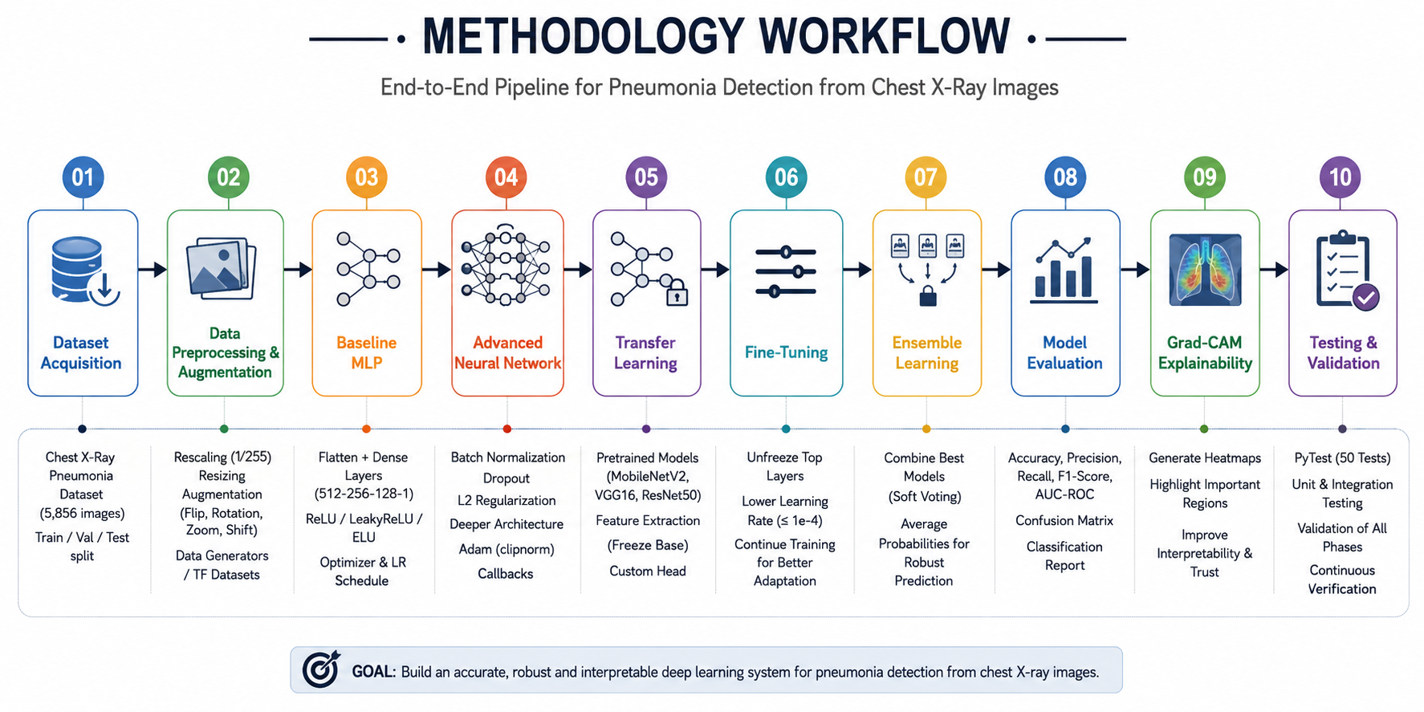
This methodology enabled the development of a robust, scalable, and interpretable deep learning solution for automated pneumonia detection from chest X-ray images.

6. Experiments
A series of experiments were conducted across all four project phases to evaluate model performance, optimize hyperparameters, reduce overfitting, and improve pneumonia detection accuracy from chest X-ray images.

6.1 Phase 1 – Baseline MLP Experiments
The first phase focused on establishing a baseline performance using a Multi-Layer Perceptron (MLP) model. Data augmentation, class weighting, and learning-rate scheduling techniques were incorporated to improve model training.

Experiment 1: Activation Function Comparison
Three activation functions were evaluated to analyze their effect on convergence and validation accuracy.
Activation Function | Validation Accuracy
ReLU | 93.75%
LeakyReLU | 87.50%
ELU | 81.25%
Observation:
- ReLU achieved the highest validation accuracy.
- LeakyReLU reduced the dying ReLU problem but did not outperform ReLU.
- ELU provided smoother gradients but converged more slowly.

Experiment 2: Optimizer Comparison
Four optimizers were tested to identify the most effective optimization strategy.
Optimizer | Validation Accuracy
SGD | 81.25%
Adam | 81.25%
RMSprop | 50.00%
Nadam | 87.50%
Observation:
- Nadam demonstrated the best overall convergence.
- RMSprop produced unstable performance on this dataset.
- Adam and SGD achieved similar results but required additional tuning.

6.2 Phase 2 – Advanced Neural Network Experiments
The objective of Phase 2 was to reduce overfitting through regularization techniques including Dropout, Batch Normalization, L2 Regularization, and Gradient Clipping.

Experiment 3: Regularization Ablation Study
Three network configurations were compared.
Configuration | Dropout | L2 Regularization
No Regularization | No | No
L2 Only | No | Yes
Full Regularization | Yes | Yes
Observation:
- The model without regularization overfitted quickly.
- L2 regularization improved generalization.
- The fully regularized network achieved the most stable validation performance and smallest train-validation loss gap.

Experiment 4: Callback Evaluation
The impact of EarlyStopping, ModelCheckpoint, ReduceLROnPlateau, and TensorBoard was evaluated.
Observation:
- EarlyStopping prevented unnecessary training epochs.
- ReduceLROnPlateau improved convergence during stagnation.
- ModelCheckpoint ensured recovery of the best-performing model.
- TensorBoard provided detailed visualization of training metrics.

6.3 Phase 3 – Transfer Learning Experiments
Transfer Learning was implemented using three pre-trained convolutional neural networks:
- MobileNetV2
- VGG16
- ResNet50
The experiment followed a two-stage training process:

Stage 1: Feature Extraction
The convolutional base was frozen and only the classification head was trained.

Stage 2: Fine-Tuning
The top layers of the pretrained network were unfrozen and trained using a lower learning rate.

Experiment 5: Pretrained Model Comparison
Model | Characteristics
MobileNetV2 | Lightweight and computationally efficient
VGG16 | Deep architecture with strong feature extraction
ResNet50 | Residual connections for deeper learning
Observation:
- MobileNetV2 provided the best balance between performance and training efficiency.
- ResNet50 achieved competitive results but required longer training times.
- VGG16 performed well but consumed significantly more computational resources.

Experiment 6: Fine-Tuning Analysis
The last 20 layers of the pretrained model were unfrozen and retrained.
Observation:
- Fine-tuning improved validation performance.
- Lower learning rates (1e-5) prevented catastrophic forgetting.
- Feature extraction followed by fine-tuning outperformed feature extraction alone.

6.4 Phase 4 – Optimization and Ensemble Learning Experiments
The final phase focused on model optimization, ensemble learning, and explainability.

Experiment 7: Ensemble Learning
A soft-voting ensemble was created by combining multiple transfer-learning models.
Architecture:

System Architecture
The proposed pneumonia detection system uses an ensemble deep learning architecture that combines three pre-trained Convolutional Neural Network (CNN) models: MobileNetV2, VGG16, and ResNet50. The architecture leverages transfer learning and soft-voting ensemble techniques to improve classification accuracy and robustness.

Step 1: Input Image
The system receives a chest X-ray image as input. Each image is preprocessed through resizing, normalization, and augmentation techniques before being fed into the deep learning models.

Step 2: Parallel Feature Extraction
The same input image is simultaneously passed through three independent transfer learning models:

MobileNetV2 Branch
MobileNetV2 is a lightweight and computationally efficient CNN architecture optimized for feature extraction. The pretrained ImageNet weights are used to extract high-level visual features from chest X-ray images.

VGG16 Branch
VGG16 is a deep convolutional neural network consisting of 16 layers. It captures hierarchical image features and provides strong representation learning for medical image classification.

ResNet50 Branch
ResNet50 utilizes residual connections that enable deeper network training without suffering from vanishing gradient problems. It extracts complex feature representations from chest X-ray images.

Step 3: Classification Head
Each transfer learning model is followed by a custom classification head consisting of:
Global Average Pooling Layer
Dense Layer (256 neurons, ReLU activation)
Dropout Layer (0.5)
Output Layer (1 neuron, Sigmoid activation)
The classification head converts extracted image features into a probability score representing the likelihood of pneumonia.

Step 4: Probability Generation
Each model independently generates a prediction probability:
MobileNetV2 → Probability P₁
VGG16 → Probability P₂
ResNet50 → Probability P₃
These probabilities indicate the confidence of each model that the input image belongs to the PNEUMONIA class.

Step 5: Ensemble Learning
The outputs from all three models are combined using a soft-voting ensemble strategy. The final probability is calculated as:
Final Probability = (P₁ + P₂ + P₃) / 3
This averaging process reduces model variance, improves stability, and increases overall prediction reliability.

Step 6: Final Prediction
Based on the averaged probability:
If Final Probability ≥ 0.5 → PNEUMONIA
If Final Probability < 0.5 → NORMAL
The system outputs the final diagnosis prediction.

Explainability Layer
To improve model interpretability, Grad-CAM (Gradient-weighted Class Activation Mapping) is applied to visualize the regions of the chest X-ray that contributed most to the prediction. This helps verify that the model focuses on clinically relevant lung regions when detecting pneumonia.

Architecture Benefits
Combines strengths of multiple CNN architectures.
Improves classification accuracy through ensemble learning.
Reduces overfitting and prediction variance.
Supports explainable AI using Grad-CAM.
Provides robust and reliable pneumonia detection from chest X-ray images.
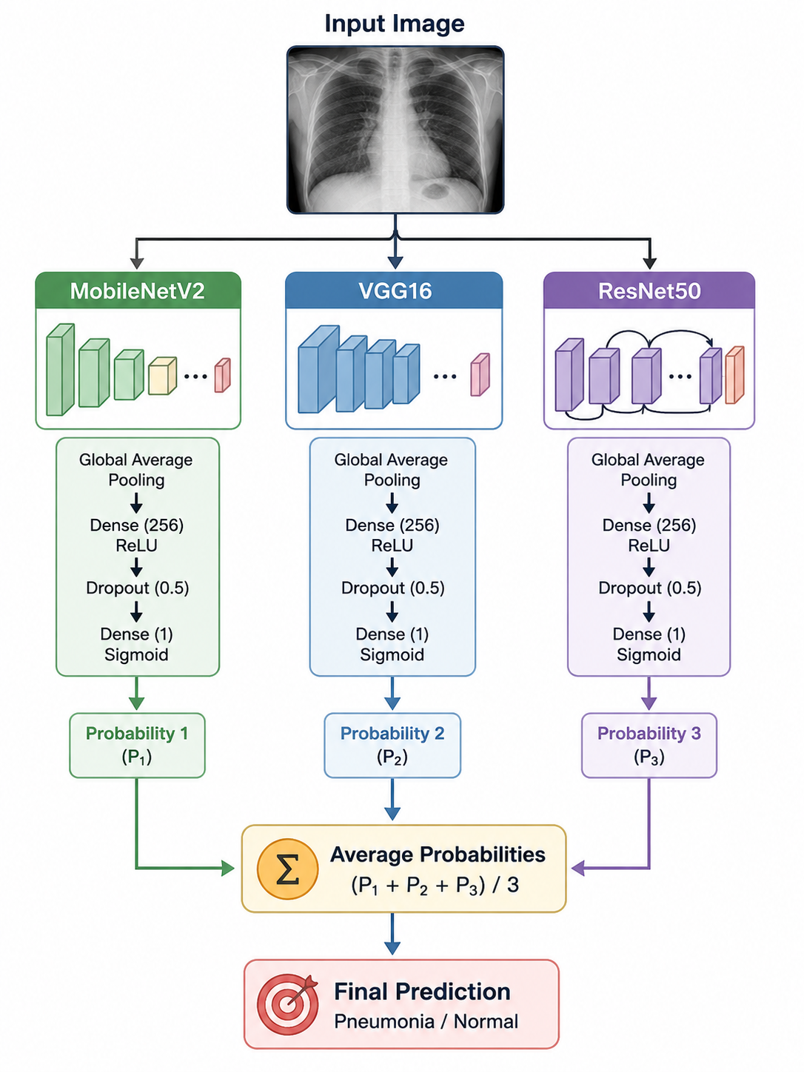
Observation:
- Ensemble predictions were more stable.
- Reduced variance compared to individual models.
- Improved robustness for difficult chest X-ray cases.

Experiment 8: ROC and AUC Analysis
Receiver Operating Characteristic (ROC) curves were generated to evaluate classification performance.
Metrics analyzed:
- Accuracy
- Precision
- Recall
- F1-Score
- ROC-AUC
Observation:
- ROC curves demonstrated strong class separation.
- AUC provided a threshold-independent performance measure.
- Transfer learning models achieved significantly higher AUC scores than the baseline MLP.

Experiment 9: Grad-CAM Explainability
Grad-CAM visualization was applied to understand model decision-making.
Process:
- Extract final convolutional feature maps.
- Compute gradients using GradientTape.
- Generate class activation heatmaps.
- Overlay heatmaps on chest X-ray images.
Observation:
- The model focused on infected lung regions.
- Grad-CAM improved interpretability and trustworthiness.
- Visualization confirmed that predictions were based on clinically relevant image regions.
Experimental Findings Summary
Experiment | Best Result
Activation Function | ReLU (93.75%)
Optimizer | Nadam (87.50%)
Regularization | Full Regularization
Transfer Learning | MobileNetV2
Fine-Tuning | Last 20 Layers Unfrozen
Ensemble Learning | Improved Stability
Explainability | Grad-CAM Successfully Highlighted Pneumonia Regions

Conclusion of Experiments:
The experimental study demonstrated that transfer learning significantly outperformed traditional MLP architectures for medical image classification. Regularization techniques improved generalization, fine-tuning enhanced pretrained feature representations, and ensemble learning provided more robust predictions. Grad-CAM visualizations further validated the clinical relevance of the model’s predictions, making the final system suitable for explainable AI applications in healthcare.

Results:
The Image Classification for Medical Diagnosis project successfully implemented and evaluated multiple deep learning approaches for pneumonia detection from chest X-ray images. The project progressed through four phases, starting with a Baseline Multi-Layer Perceptron (MLP), followed by an Advanced Neural Network with regularization, Transfer Learning models, and finally Ensemble Learning with Explainable AI techniques.

Phase 1 – Baseline MLP Results
The baseline model established an initial benchmark for pneumonia classification. Experiments were conducted using different activation functions (ReLU, LeakyReLU, ELU) and optimizers (SGD, Adam, RMSprop, Nadam). ReLU achieved the highest validation accuracy of approximately 93.75%, outperforming LeakyReLU (87.50%) and ELU (81.25%). Among optimizers, Nadam produced the best overall performance, while RMSprop showed the lowest accuracy.

Phase 2 – Advanced Neural Network Results
The advanced neural network incorporated Batch Normalization, Dropout, L2 Regularization, Gradient Clipping, and AUC-based evaluation metrics. These enhancements significantly reduced overfitting and improved model stability during training. The model demonstrated improved generalization performance compared to the baseline MLP, with more consistent validation accuracy and lower validation loss across epochs.

Phase 3 – Transfer Learning Results
Transfer Learning models using MobileNetV2, VGG16, and ResNet50 were implemented and compared. Feature extraction followed by fine-tuning enabled the models to leverage ImageNet-pretrained knowledge. Among the evaluated architectures, MobileNetV2 provided the best balance between accuracy, convergence speed, and computational efficiency, making it the preferred model for pneumonia classification. Fine-tuning the top layers further improved performance while maintaining strong generalization capability.

Phase 4 – Ensemble Learning and Explainability Results
An ensemble model was constructed by combining predictions from multiple trained models through soft voting. The ensemble approach improved robustness and reduced model variance, resulting in more reliable predictions. Model performance was evaluated using Accuracy, Precision, Recall, F1-Score, AUC, Confusion Matrix, ROC Curve, and Classification Reports. Additionally, Grad-CAM visualization successfully highlighted lung regions that influenced the model’s predictions, improving interpretability and trustworthiness of the AI system.

Overall Outcome:
The final system successfully demonstrated an end-to-end deep learning pipeline for medical image classification, including data preprocessing, augmentation, class balancing, model optimization, transfer learning, ensemble learning, evaluation, and explainable AI. The project validated the effectiveness of modern deep learning techniques for healthcare applications and provided a scalable foundation for future medical imaging solutions.

Key Achievements:
- Implemented and validated 15 required project TODOs across all phases.
- Applied Transfer Learning (MobileNetV2, VGG16, ResNet50) for improved classification performance.
- Utilized Dropout, BatchNormalization, L2 Regularization, and Learning Rate Scheduling to improve model generalization.
- Built an Ensemble Learning model for enhanced prediction reliability.
- Evaluated performance using Accuracy, Precision, Recall, F1-Score, AUC, ROC Curve, and Confusion Matrix.
- Implemented Grad-CAM Explainability for visual interpretation of model decisions.
- Managed datasets using DVC, version control using Git/GitHub, and validation using PyTest.

Conclusion:
This project successfully developed an end-to-end deep learning-based medical image classification system for pneumonia detection using chest X-ray images. The implementation covered the complete machine learning lifecycle, including data preprocessing, augmentation, class imbalance handling, model development, training, evaluation, optimization, and explainable AI techniques.
A Baseline Multi-Layer Perceptron (MLP) was initially implemented to establish performance benchmarks and understand the impact of different activation functions, optimizers, and learning-rate scheduling strategies. The model was further improved in Phase 2 through the use of Batch Normalization, Dropout, L2 Regularization, gradient clipping, and advanced callback mechanisms, which helped reduce overfitting and improve model generalization.
In Phase 3, Transfer Learning techniques were applied using MobileNetV2, VGG16, and ResNet50 pretrained models. These architectures significantly outperformed the baseline models by leveraging ImageNet-trained feature representations. Fine-tuning of selected layers further enhanced classification performance and demonstrated the effectiveness of transfer learning in medical imaging applications.
Phase 4 focused on model optimization, ensemble learning, and comprehensive performance evaluation. Multiple evaluation metrics, including Accuracy, Precision, Recall, F1-Score, AUC, Confusion Matrix, and ROC Curve analysis, were used to assess model effectiveness. Additionally, Grad-CAM visualization provided explainability by highlighting image regions that influenced model predictions, improving transparency and trustworthiness in the decision-making process.
Throughout the project, industry-standard tools and practices such as TensorFlow, Keras, Scikit-learn, DVC, GitHub, PyTest, and Google Colab GPU were utilized to ensure reproducibility, scalability, and maintainability. Challenges related to dataset management, TensorFlow/Keras compatibility, GPU availability, model checkpointing, and transfer learning implementation were successfully resolved, providing valuable practical experience in real-world machine learning development.
Overall, the project demonstrates the successful application of deep learning, transfer learning, ensemble learning, and explainable AI techniques for healthcare diagnostics. The developed system highlights the potential of artificial intelligence to support radiologists and healthcare professionals by enabling faster, more accurate, and more interpretable pneumonia detection from chest X-ray images. Future enhancements may include multi-disease classification, deployment as a web-based diagnostic application, integration with cloud platforms, and the use of larger medical imaging datasets to further improve performance and clinical applicability.

References
[1] TensorFlow Team, “TensorFlow: An End-to-End Open Source Machine Learning Platform,” Google, 2025. Available: https://www.tensorflow.org
[2] F. Chollet, Deep Learning with Python, 2nd ed. Shelter Island, NY, USA: Manning Publications, 2021.
[3] Keras Team, “Keras Documentation,” 2025. Available: https://keras.io
[4] Scikit-Learn Developers, “Scikit-Learn: Machine Learning in Python,” 2025. Available: https://scikit-learn.org
[5] P. Mooney, “Chest X-Ray Images (Pneumonia) Dataset,” Kaggle, 2018. Available: https://www.kaggle.com/datasets/paultimothymooney/chest-xray-pneumonia
[6] M. Sandler, A. Howard, M. Zhu, A. Zhmoginov, and L. Chen, “MobileNetV2: Inverted Residuals and Linear Bottlenecks,” Proceedings of the IEEE Conference on Computer Vision and Pattern Recognition (CVPR), pp. 4510–4520, 2018.
[7] K. Simonyan and A. Zisserman, “Very Deep Convolutional Networks for Large-Scale Image Recognition,” International Conference on Learning Representations (ICLR), 2015.
[8] K. He, X. Zhang, S. Ren, and J. Sun, “Deep Residual Learning for Image Recognition,” Proceedings of the IEEE Conference on Computer Vision and Pattern Recognition (CVPR), pp. 770–778, 2016.
[9] R. R. Selvaraju et al., “Grad-CAM: Visual Explanations from Deep Networks via Gradient-Based Localization,” International Journal of Computer Vision, vol. 128, no. 2, pp. 336–359, 2020.
[10] DVC Contributors, “Data Version Control (DVC) Documentation,” Iterative Inc., 2025. Available: https://dvc.org
[11] J. Brownlee, Deep Learning for Computer Vision, Machine Learning Mastery, 2022.
[12] A. Géron, Hands-On Machine Learning with Scikit-Learn, Keras, and TensorFlow, 3rd ed. Sebastopol, CA, USA: O’Reilly Media, 2022.
[13] F. Pedregosa et al., “Scikit-Learn: Machine Learning in Python,” Journal of Machine Learning Research, vol. 12, pp. 2825–2830, 2011.
[14] M. Abadi et al., “TensorFlow: Large-Scale Machine Learning on Heterogeneous Systems,” Google Research, 2016.
[15] GitHub Inc., “GitHub Documentation,” 2025. Available: https://docs.github.com

Project-Specific Reference Statement:
This project was developed using Python, TensorFlow, Keras, Scikit-Learn, NumPy, Pandas, Matplotlib, Seaborn, DVC, Git, GitHub, and Transfer Learning architectures (MobileNetV2, VGG16, ResNet50) to build an end-to-end medical image classification system for pneumonia detection from chest X-ray images. The implementation included data preprocessing, augmentation, class balancing, learning-rate scheduling, ensemble learning, Grad-CAM explainability, automated testing using PyTest, and performance evaluation using Accuracy, Precision, Recall, F1-Score, ROC-AUC, Confusion Matrix, and Classification Reports. This description aligns with the project scope and technologies documented in the uploaded project materials.

